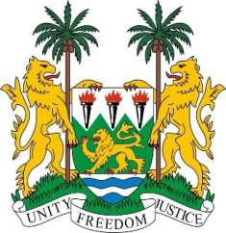
SIERRA LEONE
23rd Session of the UPR

AUSTRIA

9 November 2015

Mr President,

Sierra Leone welcomes the delegation of Austria and thanks them for their presentation.

My delegation commends the progress made since their last review cycle which included becoming a signatory to the ICPPED and OP-CAT, as well as withdrawing reservation to the CEDAW. Sierra Leone also applauds the wide-ranging measures taken in ordinary law to address various issues, including the conviction for hate speech and promoting fairness for foreign workers.

Sierra Leone further notes with interest the efforts currently underway to establish a comprehensive national human rights action plan and would urge Austria to expedite this process.

However, Sierra Leone encourages Austria to take measures to increase the representation of women in decision making positions, to facilitate family reunification and to improve the situation of migrants and asylum seekers.

Recommendations:

- Submit the overdue report to the CPPED
- Comprehensively investigate incidents and allegations of hate crimes and xenophobic attacks and bring their perpetrators to justice.
- Investigate incidents of human trafficking and offer full assistance to child trafficking victims.

In conclusion, my delegation notes, with appreciation that Austria has consistently contributed financially to the OHCHR since 2011.

Sierra Leone wishes Austria success in completing its review.

Thank you, Mr President.

